Greening Chiddingly Meeting
Wednesday 27 April 2022
Six Bells, Chiddingly

Notes

Attendees
 | David Nash (Chair) | Mark Valleley (Secretary) | Dylan Walker
 | Mike Goss | Sheryl Renninson | Noel Hardy
 | Jenny Howells | Helen Denning | Tina Letanka
 | Wendy Stayhill? | Peter Gunner | Emily Ticehurst
 | -
 | Apologies
 | Sally Ashby | Winnow Hardy | Stuart Hall
 | Laura Johnstone | Lucy Carnagan-Holt | Gail Giles

Item | Action
- Welcome and notes from the previous meeting
  - David Nash welcomed everybody to the fifth meeting of the group.
  - Actions from last meeting reviewed. Majority to be dealt with under items on the agenda.

- Website development
- Now that the group had confirmed its new name ‘Greening Chiddingly’ Stuart had purchased a domain name.  - Dave had drafted five of the themed webpages. (Home page, Cutting back on flying, reducing your energy use, making your voice heard by those in power, thinking about where you invest). A copy of the draft website structure is included in Annex 1.  - The homepage would include a menu of themed pages aimed at giving individuals the information needed to make more informed choices. Pages on reducing your car use, talking about the changes you make, and kids page still to be drafted.  - As agreed at the last meeting, he needed help from the following people: on the following pages:  - Eating less meat and dairy – Helen (with support from Lucy?)  - Reducing consumption and waste - Sheryl  - Respecting and enhancing green spaces - Sally  - Thinking about where you invest – Sheryl  - Dave to liaise with individuals name above by email about their input into these pages  - David to approach Lucy and Cat about producing content for Kids Page  - Gail Giles’ daughter Callista had been unable to draft a logo for the group due to coursework pressure.  - Dave circulated copies of some drafts of ‘holding’ logos he had produced.  - Further work could be done on a logo design once website was up and running. Dylan suggested doing a group logo design exercise at a future meeting. People bring along or circulate by WhatsApp copies of logos or design ideas that they like, and these are then used to help set the design specification for a logo. | HD &LCH  SR  SA  SR  DN  DN
- Event planning
- Green Weekend  - Sheryl confirmed date for the Eco Open Houses and Jumble Trail event as Saturday 20 August 2022.  - Jumble trail is a car boot sale but on your doorstep. Communal spaces would be identified for people not having drives on which they could position stalls. Possibility of yard next to village shop. People asked to register and a map produced showing where stall would be so people can then follow a jumble trail.  - The Eco Open House would enable those who have made adjustments to their home or garden to reduce their carbon footprint or increase biodiversity to showcase these improvements to others in the village.  - Marketing activity could involve:  - Poster  - Flyer  - Stall at village fete  - Publicity via other channels – website, parish news.  - Need a small subgroup to plan the event. Sheryl and Dave agreed to start this.  - Other volunteers sought to participate in the Green Weekend event planning sub-group.  - A discussion took place about whether to have a guest speak to launch the Green Weekend either on the Friday evening or on the Saturday morning. Consensus reached that would be better to have a speaker in winter months when no other activities planned.  - Community Cycling Event  - Mark gave an update. Aim of event is to give less familiar cyclists an opportunity to get out on their bikes, increase their confidence and consider using their bikes more for local journeys.  - Mark circulated a map showing two potential routes with the plan that both would start at the Village Shop. The map is included in Annex 2. A shorter 3 mile route would follow Scrapers Hill, Smithlands Lane, Honeywick Lane, Parsonage Lane and The Street. The longer 6 mile route would follow Scrapers Hill, Smithlands Lane, Stalkers Lane, Ailies Lane, Highlands Lane and the Street.  - Mike had obtained information form Cycling UK about organising cycling events which included information on risk assessment and insurance. A key issue was to determine whether public liability insurance was needed. Mike’s view was that this was not compulsory. Mark’s view was that if we are organising an event that we are inviting people to attend there could be issues in the unlikely event that someone had an accident. Mike had identified that it may be possible to get public liability insurance through affiliate membership of Cycling UK which would cost £85. This may mean that we would need to be constituted in some way. Another option may be to get a local cycling group involved in the event who already have insurance cover in place.  - Mike to investigate these options further including the potential involvement of a local cycling group.  - The potential date for the cycling event was Saturday 17 September.  - Mike to liaise with the shop manager about the possibility of holding the cycling event on 17 September.  - In order to take the cycle event planning forward a subgroup would be needed. Mark and Mike agreed to participate and Sheryl said her husband Will would also be potentially be willing to participate.  - Mark to liaise with Mike and Will to set up the first cycle event planning meeting. | SR/DN  ALL  MG  MG  MV
- Communications
- Attendance at Annual Assembly 24 May 2022  - The Parish Clerk had invited a member of the group to speak for 5 minutes about the group and its annual activities at the Annual Assembly.  - Dylan agreed to attend to represent the group at the meeting.  - Village Fete - 11 June 2022  - Sheryl said that the group had been given the option to have a stall at the Village Fete on 11 June. This would be an opportunity to promote the forthcoming events, raise the profile of the group and attract new members. A flyer for the forthcoming events would need to be available to distribute and the website would also need to be up and running as details of it would be shown on the flyer.  - A discussion took place about the ideas for activities for the stall. A Chiddingly Green Map idea was discussed, which would involve people being able to mark up areas where greening activity was already in place that they were proud of and wanted to celebrate and identify places where activity was needed or could be undertaken.  - The idea of a ‘green game’ on the stall was discussed e.g. ‘How many seeds in the jar’? ‘Which of these items is recyclable’?  - Frankie and Emily agreed to work up some potential green game ideas for discussion at the next meeting.  - Sheryl to confirm stall booking with village fete organiser.  - Further discussion at next meeting about arrangements for the stall at the next meeting.  - Communication methods  - Due to time constraints a brief discussion took place about the mechanisms to publicise the groups’ activities. Agreed to continue to use existing channels, WhatsApp, Facebook, Parish News, Parish Notice Boards and Posters. | DW  FH & ET  SR  ALL
- Any other business
- Dylan identified the potential need for the group to become a formal entity, particularly if it were to become engaged in fund raising or asking participants to pay entry fees for events. This would potentially require it to have a bank account with named account holders. A community bank account was put forward as an option.  - Further discussion about this would need to take place at the next meeting.  - Date and time of next meeting: 19.30 Thursday 19 May 2022 – Back Bar, Six Bells  Dates for future meetings: Weds 29 June, Weds 27 July, Weds 31 Aug, Weds 28 Sept, Weds 26 Oct, Weds 30 Nov. | ALL

Annex 1- Website Structure

GREENING CHIDDINGLY GROUP - WEBSITE STRUCTURE
Page | Themes on page
- Home page | - Welcome message;  - Events;  - Social media feeds
- Reducing your car use | - Alternatives to petrol car use (car-sharing, cycling, electric car hire, electric taxis);  - Switching to an electric/hybrid vehicle
- Cutting back on flying | - Alternatives to flying;  - Carbon offsetting
- Eating less meat and dairy | - Need help here
- Reducing your energy use (and bills) | - Reducing domestic energy use;  - Switching to renewables;  - Green energy providers
- Reducing consumption and waste | - Need help here
- Respecting and enhancing green spaces | - Need help here
- Making your voice heard by those in power | - Contact your MP;  - Wealden Council;  - Parish Councillors
- Thinking about where you invest | - Banks;  - Private pensions;  - Mortgages
- Talking about the changes you make | - Tips on successful climate conversations
- Kids page | - Need help here
- Directory of services | - Thematic listings
- Organisational notes | - Meeting notes;  - Past events
- Get in touch | - Email or message function
Annex 2 ‘Tour De Chiddingly’ Cycle Routes
Short Route – 3 miles
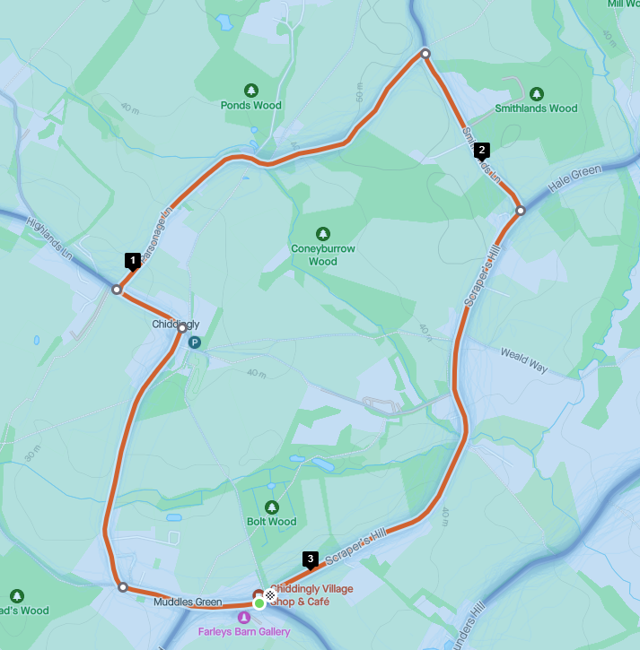
Church
Pub

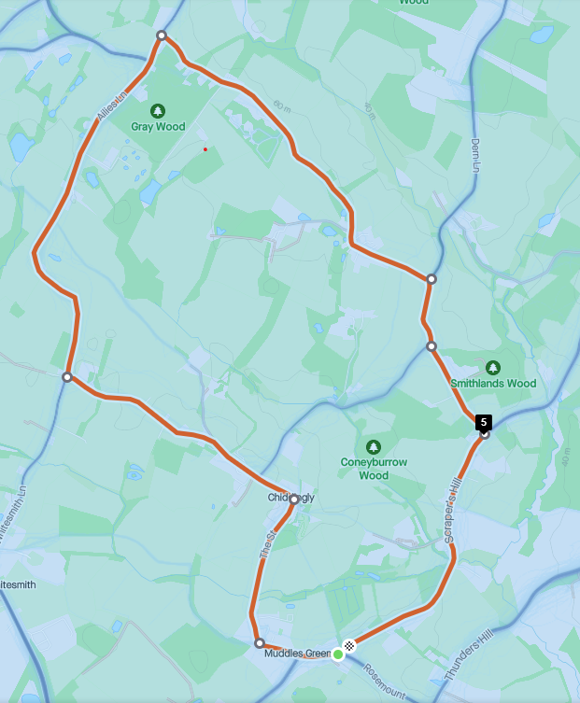
Tour de Chiddingly - Longer route – 6 miles
Stalkers Lane
Ailies Lane
Village shop
Church
Pub

